
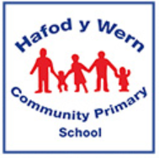

Dosbarth Lan Y Mor - Autumn Term Newsletter 2025

Dear Parents/Carers,
Welcome back to the start of the new academic year. All the children have enjoyed exploring in class, getting to know their new class friends and meeting the staff in class. This letter outlines some key information for you for this term. Should you require any further information please ask a member of staff. We are looking forward to a busy but exciting term ahead!
Staff in Class
Class Teacher – Mrs A Donoher
Teaching Assistants - Miss Jones and Mrs Davies
Topic this term…
Our topic for this half term is ‘Croeso’. The children will be completing lots of activities to getting to know each other better. Throughout the half term they will be creating items to go in a special box all about themselves. They will create a family tree and talk about people who are important to them. They will learn all about the five senses that help them to explore and discover the world around them. They will get artistic by drawing their own self-portrait. In Jigsaw work this term, the children will be focusing on
the themes ‘Being Me in My
World’ and ‘Celebrating
Differences’.

P.E
Our PE day is a Tuesday. On this day your child can come into school wearing their PE kit. PE kit is as follows:

White PE t-shirt, black/blue/grey shorts or jogging bottoms, black leggings, school jumper/cardigan.


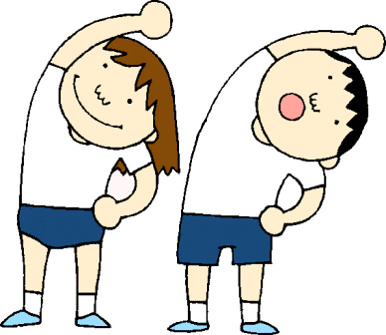


Snack

Children can choose to have a healthy snack in school each day. The cost for this is £1 per week. This should be paid in cash to the class teacher. Snack can be paid weekly, or alternatively you can pay £8 for the half term.
Home Learning and Reading

Children will be sent home with their digital passports and Seesaw codes.
The digitial passports contain passwords for Bug Club and Hwb.

Bug Club www.activelearnprimary.co.uk

Bug Club can be used to access a variety of books and fun reading activties online.

Reading books will be sent home weekly on a Monday and need to be returned on a Thursday.

Please can you write a comment in your childs yellow reading record to let us know how they are getting on with reading at home.
Thank you.

Outdoor Classroom

Our outdoor day will be a Wednesday. On this day children will spend time working in our outdoor classroom.
Children should be dressed for working outdoors with a coat and change of shoes or wellies in a labelled bag.
Thank you for
your cooperation.



Seesaw codes have been sent home. This will enable parents/carers to see what work children have been getting up to in school. School letters, reminders and important information will also be shared on Seesaw.


